Tools Required:

- 10 & 17mm sockets
- 6mm allen key
- Phillips & slot screwdrivers
- Needle nose pliers
- Vise grips
- Trim removal tool for removing kick panel

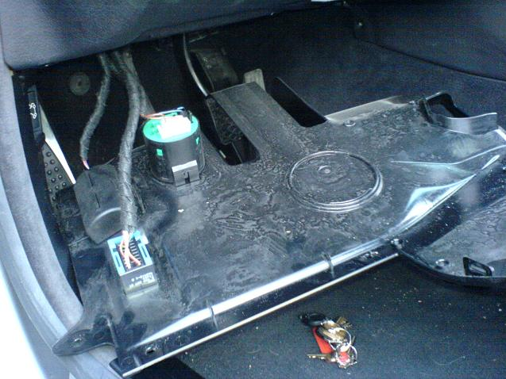
Step 1 – Removing the kick panel:
  - Using a Phillips head screwdriver remove the three screws on the left hand side.
  - Remove the trim plug on the right hand side.
  - Remove the trim plug at the back, by the accelerator pedal, by turning.
  - Release the two trim clips by pulling down around the steering column. Pull the kick panel towards you then down to free it from the dash.
  - Slide the blue lock on the OBD connector then push up to free the connector.
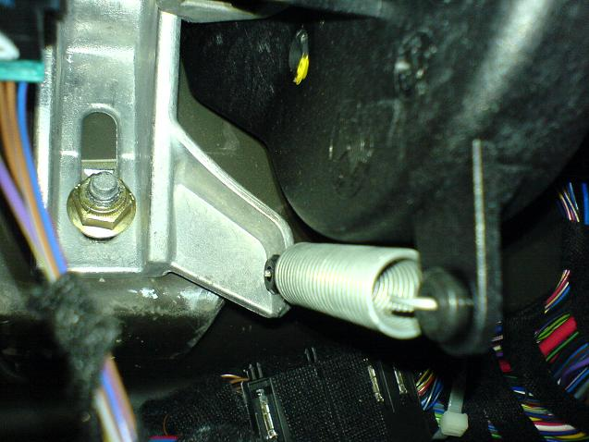
  - Unplug the two plugs in the green connector and the one plug in the light.
Step 2 – Removing the stock clutch pedal:
- Using needle nose pliers, pull the spring off the pedal.
- Use a short common slot screwdriver to remove the pivot pin by inserting between the edge of the hole and the grey pin and pushing. Simultaneously compress the tabs with very small needle nose pliers.
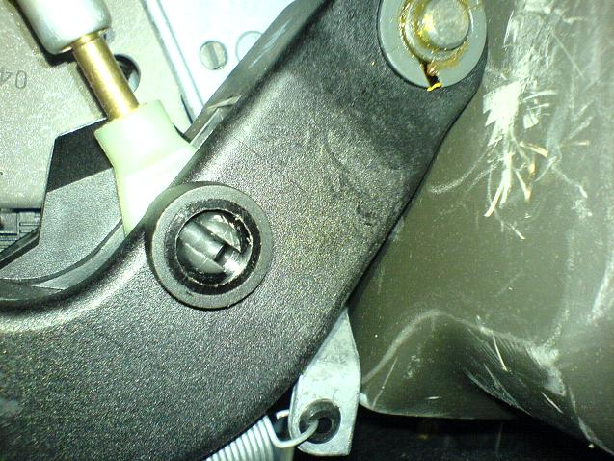
- Using a long common slot screwdriver pry the edge of the pin lock clip open and slide off the pin. Notice there is an opening on one side of the clip.
- Using a 10mm socket remove both bolts holding the clutch actuator to the clutch rebound stop panel closest to the seat. Pivot the clutch rebound stop panel out of the way and pull the clutch pedal towards the seat to free the end from the clutch actuator.
- Slide the pedal off the pivot pin.
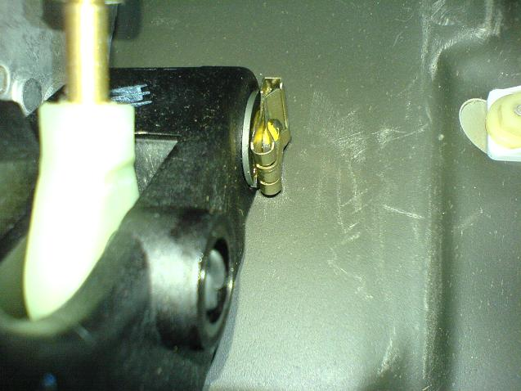
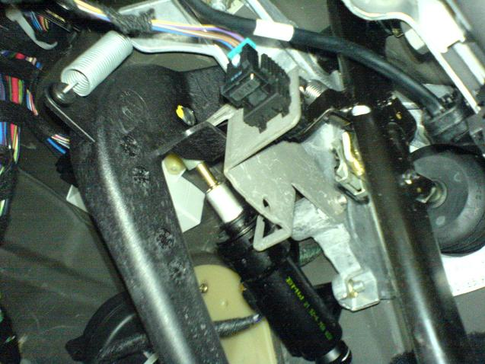
Step 3 – Transfering Parts:
- Remove the spring rubber grommet and both sides of the pivot pin sleeves from the stock pedal and replace on the Mason Engineering clutch pedal. Some installers have reported that they have found Windex to be helpful in fitting the rubber grommet onto the Mason Engineering clutch pedal.
- Transfer the rubber cover from the stock pedal to the Mason Engineering clutch pedal starting from the bottom edge.
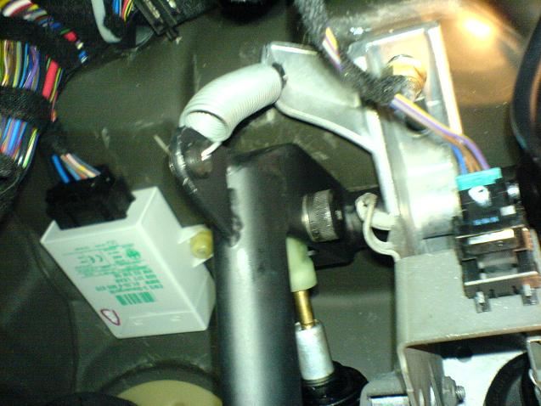
- The stock clutch pedal rests against the clutch rebound stop panel. This is not a problem with the grey locking pin used on the stock clutch pedal however it will interfere with the horizontal movement eliminating bolt used on the Mason Engineering clutch pedal. You will need to use vise grips to bend this piece to avoid any interference.
Step 4 – Installing the Mason Engineering Clutch Pedal:
- Slide the pedal onto the pivot pin and move until it slips over the end of the clutch actuator.
- Insert the bolt and locking nut which were provided with the Mason Engineering Clutch Pedal then tighten using a 6mm allen key and a 17mm socket.
- Use the 10mm socket to reattach the clutch rebound stop panel to the clutch actuator.
- Using needle nose pliers replace the spring on the pedal.
Step 5 – Reinstalling the kick panel:
- Reattach all four clips.
- Slide the panel in, watching fro the plastic guide above the dead pedal.
- Reinstall the three screws, the turning trim lock by the accelerator, and the push trim lock.

Please note that you will notice an immediate difference in shifting. Users have reported that it can take several days to adjust to the feel and use of a Mason Engineering Clutch Pedal versus the stock pedal. Several have reported a few stalls until they because familiar with the quicker clutch engagement. On the flipside returning to a vehicle with a stock clutch pedal can leave you driving like you’ve never used a stick before.

